**No file for dataset ids to loop over so I designed mine.**

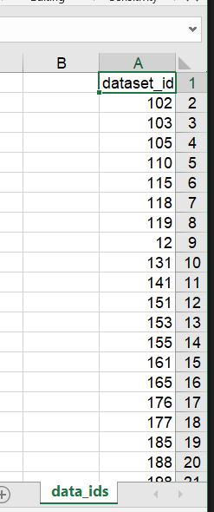

**Lags:**

He mentioned that the task requires at least lag 4 to work but didn't define lag or datasets ids in excel sheet like the rest so I had to design it myself and used fixed lag 4 as he didn't specify which is best to use.

**Handling Missing Values:**

Not handling NAN

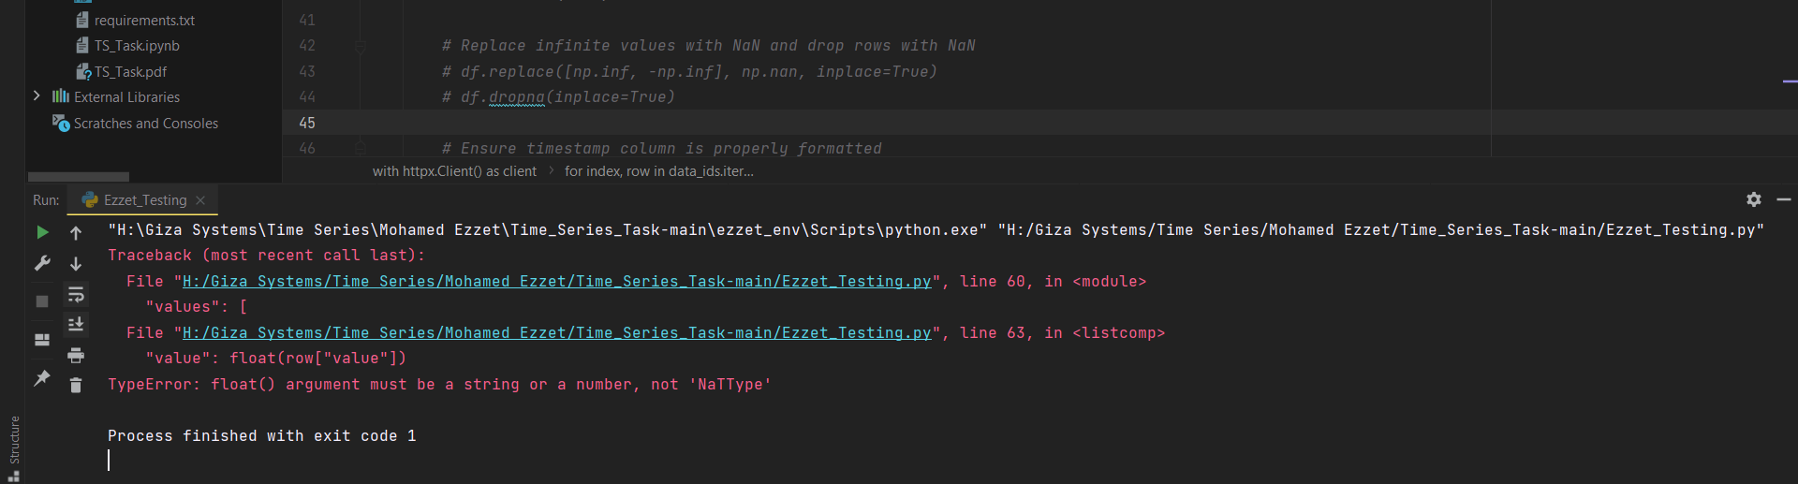

**Handling "anomaly":**

I used the script that have the part of sending "anomaly" column if the sanded dataset has it, **it nearly worked fine, but not on 119, 204, 348, 506**

**Note: THIS actually happens with and without sending "Anomaly", and with different lag values.**

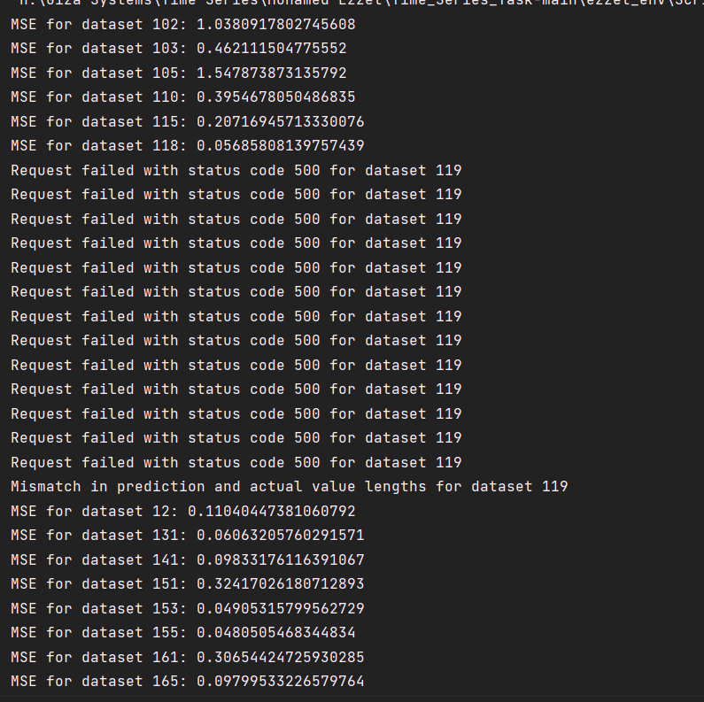





**So, we have about 92 datasets only recorded.**